**CSA1140 Object Oriented Analysis And Design For Project**

* Draw the UML Diagrams for Library Management System and generate the Skeleton Code accordingly.

USECASE DIAGRAM: 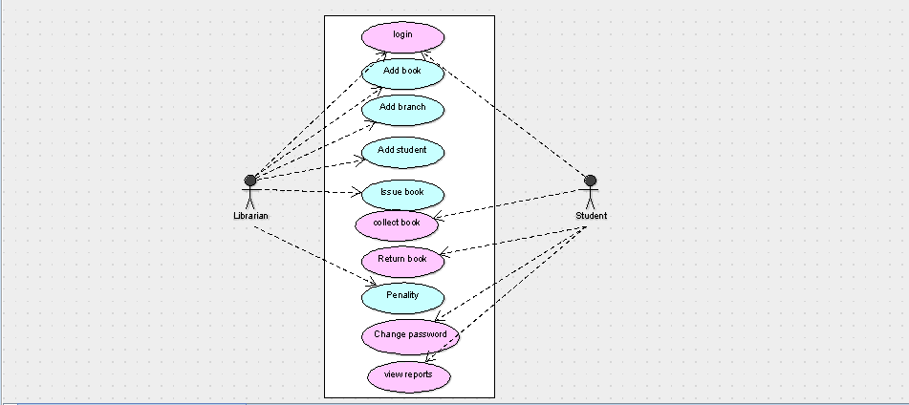

CLASS DIAGRAM:

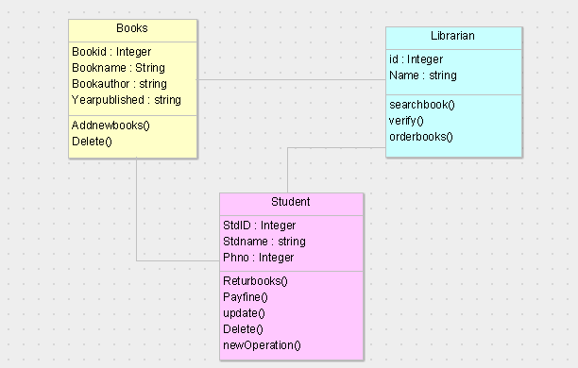

SKELETHON CODE:

import Logical View.Datatypes.string;

import java.util.Vector;

public class Student {

public Integer StdID;

public string Stdname;

public Integer Phno;

public Vector myBooks;

public Vector myLibrarian;

public void Returbooks() {

}

public void Payfine() {

}

public void update() {

}

public void Delete() {

}

public void newOperation() {

}

}

SEQUENCE DIAGRAM:

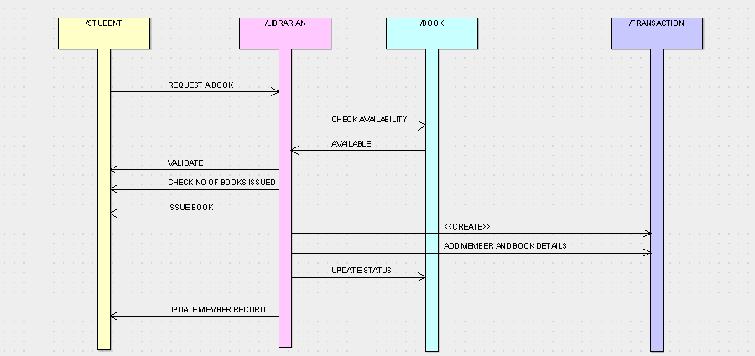

COLLOBORATION DIAGRAM:

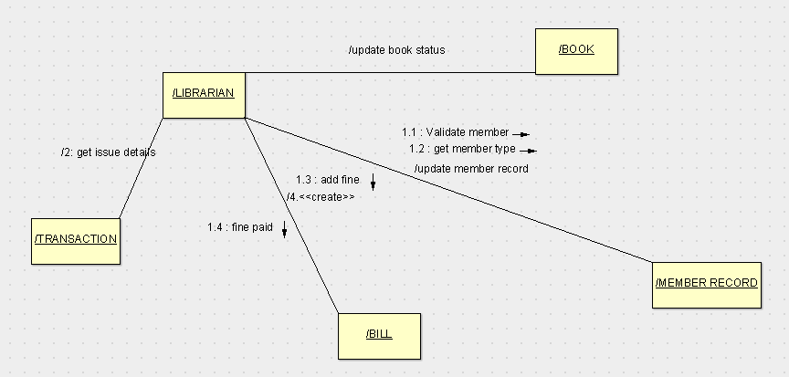

STATE CHART DIAGRAM:

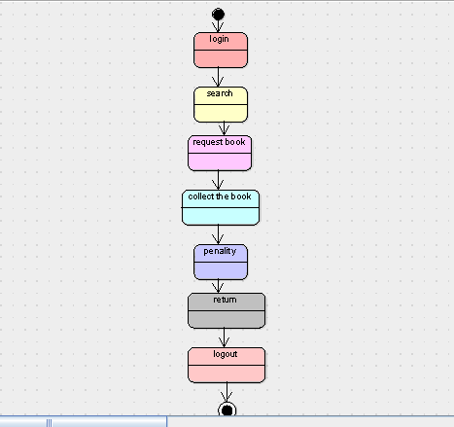

ACTIVITY DIAGRAM:

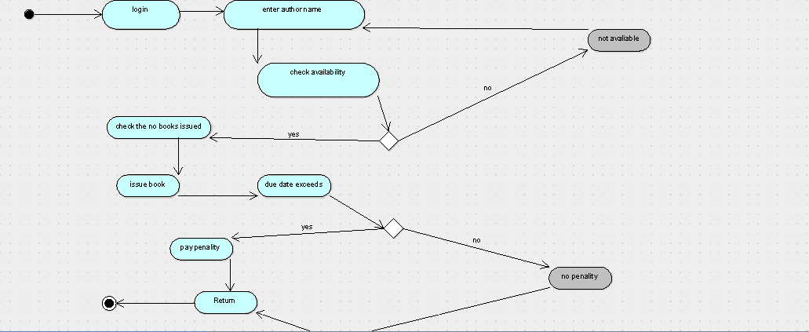

COMPONENT DIAGRAM:

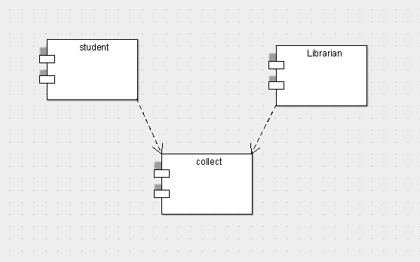

DEPLOYMENT DIAGRAM:

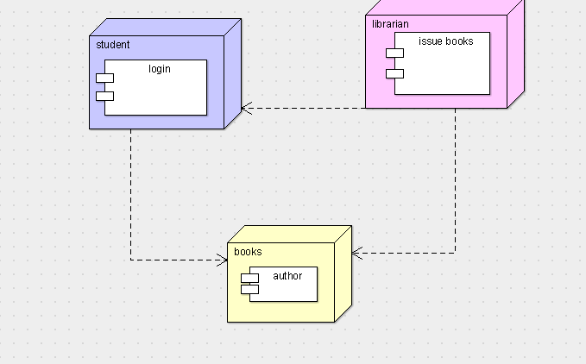

PACKAGE DIAGRAM:

